UNIVERSITY OF WAH (UOW)

DEPARTMENT OF COMPUTER SCIENCE



COURSE TITLE: INTRO TO INFORMATION SECURITY

COURSE CODE: CS – 251 L

SUBMITTED TO: MS. WASIFA KANWAL

SUBMITTED BY: SAADI SAFDAR

REG #: UW-24-CS-BS-088

BSCS 3RD B

LAB ASSIGNMENT # 4

Task 1: Shift Cipher Encryption
- Write a Python program that:
- Takes a message (plaintext) from the user.
- Asks for a numeric key (e.g., 5).
- Encrypts the message by shifting each alphabet letter forward by that key.
- Decrypts the resulting ciphertext back to the original message.
- Ignore non-alphabetic characters during shifting (e.g., spaces or punctuation remain unchanged).
- Test your program by encrypting the following:
“ Your Name is doing Security Lab ” with a key = 5.
Code:

def caesar_encrypt(text, key):
result = ""
for ch in text.upper():
if ch.isalpha():
result += chr((ord(ch) - 65 + key) % 26 + 65)
else:
result += ch
return result

def caesar_decrypt(cipher, key):
return caesar_encrypt(cipher, -key)

plaintext = input("Enter message: ")
key = int(input("Enter numeric key: "))

encrypted = caesar_encrypt(plaintext, key)
decrypted = caesar_decrypt(encrypted, key)

print("Encrypted:", encrypted)
print("Decrypted:", decrypted)
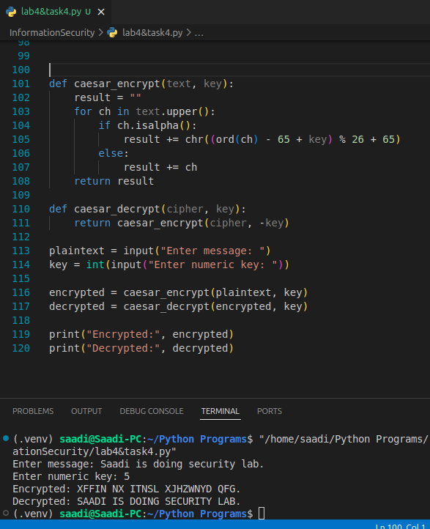

Task 2: Random Letter Substitution Cipher
- Generate a random mapping between each alphabet letter (A–Z) and its substitute letter.
- Use this mapping to:
- Encrypt a user-entered message.
- Decrypt it back to the original message using the same key map.
- The mapping should change each time the program runs (demonstrate randomness).
- Test your program by encrypting and decrypting your full name “your full name”.
Code:

import string
import random

alphabet = list(string.ascii_uppercase)
key = alphabet.copy()
random.shuffle(key)
encrypt_map = {}
decrypt_map = {}
for i in range(len(alphabet)):
encrypt_map[alphabet[i]] = key[i]
decrypt_map[key[i]] = alphabet[i]

message = input("Enter your full name: ").upper()

cipher = ""
for letter in message:
if letter.isalpha():
cipher += encrypt_map[letter]
else:
cipher += letter
plain = ""
for letter in cipher:
if letter.isalpha():
plain += decrypt_map[letter]
else:
plain += letter
print("Cipher:", cipher)
print("Decrypted:", plain)
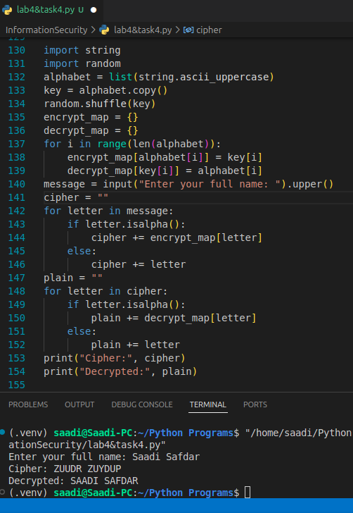
Task 3: Repeating-Shift Cipher (Vigenère Cipher)

Question for Students:
- Encrypt the name “your name” using the keyword “SECURE”.
- Fill in a table showing: Plaintext letters, repeated keyword letters, numeric shifts, and resulting ciphertext.
- Then decrypt the ciphertext to verify you get the original message.

Solution:

- Repeating the keyword to match the length of your plaintext:
  - Plaintext: S A A D I
  - Keyword: S E C U R (repeated to match length)
- Convert each letter to its numeric value (A=0, ..., Z=25):
Plaintext (P) | S | A | A | D | I
Keyword (K) | S | E | C | U | R
Shift (0–25) | 18 | 4 | 2 | 20 | 17

- Encryption:
  - Formula: C = (P + K) mod 26
  - For each letter:
    - S(18) + S(18) = 36 % 26 = 10 → K
    - A(0) + E(4) = 4 % 26 = 4 → E
    - A(0) + C(2) = 2 % 26 = 2 → C
    - D(3) + U(20) = 23 % 26 = 23 → X
    - I(8) + R(17) = 25 % 26 = 25 → Z
- Decryption:

- Formula: P = (C - K) mod 26
- For each letter:
  - K(10) - S(18) = -8 % 26 = 18 → S
  - E(4) - E(4) = 0 % 26 = 0 → A
  - C(2) - C(2) = 0 % 26 = 0 → A
  - X(23) - U(20) = 3 % 26 = 3 → D
  - Z(25) - R(17) = 8 % 26 = 8 → I
I get "SAADI" back as expected.

Plaintext (P) | S | A | A | D | I
Keyword (K) | S | E | C | U | R
Shift (0–25) | 18 | 4 | 2 | 20 | 17
Ciphertext (C) | K | E | C | X | Z

Assigned tasks in Labs:
1. Caeser Cipher Implementation

def caeser_encrypt(text, key):
result = ""
for ch in text:
if ch.isupper():
result += chr((ord(ch) - 65 + key) % 26 + 65)
else:
result += ch
return result
def caeser_decrypt(cipher, key):
return caeser_encrypt(cipher, -key)
encrypted = caeser_encrypt("HELLO", 3)
print(encrypted)
print("Decrypted:", caeser_decrypt(encrypted, 3))

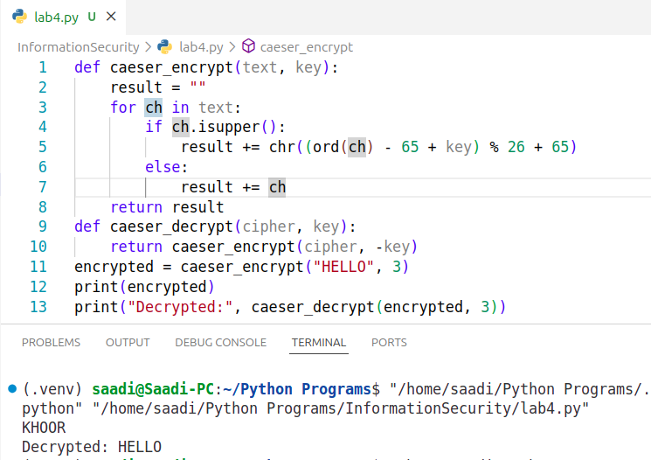
2. Monoalphabetic Cipher Implementation

import string, random
alphabet = list(string.ascii_uppercase)
print("Alphabet:", alphabet)
key = alphabet.copy()
random.shuffle(key)
print("Key:", key)
encrypt_map = {}
decrypt_map = {}
for i in range(len(alphabet)):
encrypt_map[alphabet[i]] = key[i]
decrypt_map[key[i]] = alphabet[i]

message = "HELLO"

cipher = ""
for letter in message:
if letter.isalpha():
cipher += encrypt_map[letter]
else:
cipher += letter

plain = ""
for letter in cipher:
if letter.isalpha():
plain += decrypt_map[letter]
else:
plain += letter

print("Message:", message)
print("Cipher:", cipher)
print("Decrypted:", plain)

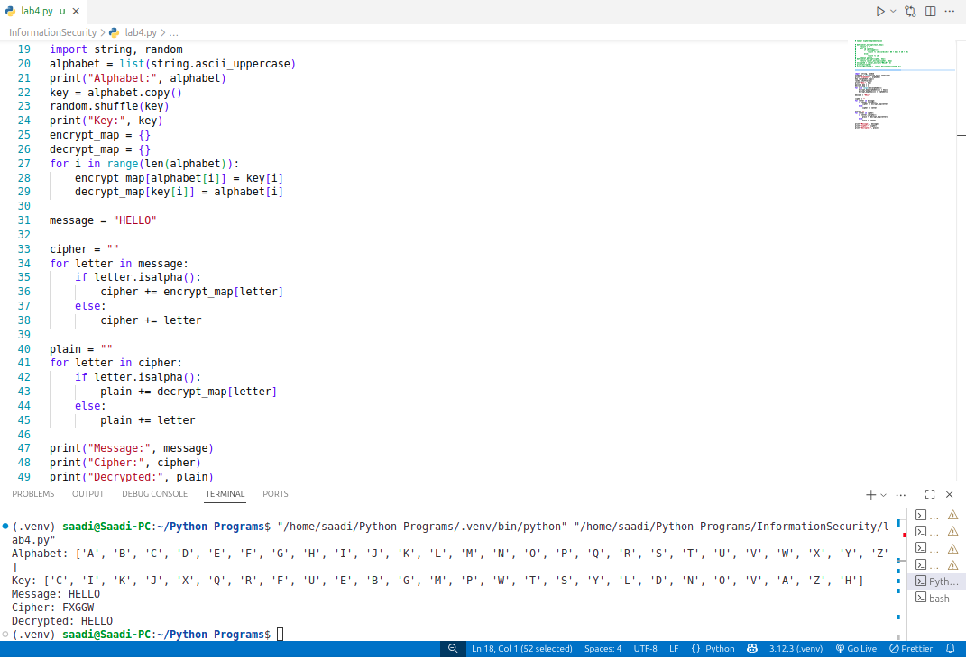
3. Vigenere Cipher Implementation
def vigenere_encrypt(text, key):
cipher = ""
key = key.upper()

for i, ch in enumerate(text.upper()):
if ch.isalpha():
shift = ord(key[i % len(key)]) - 65
cipher += chr((ord(ch) - 65 + shift) % 26 + 65)
else:
cipher += ch

return cipher

def vigenere_decrypt(cipher, key):
text = ""
key = key.upper()

for i, ch in enumerate(cipher.upper()):
if ch.isalpha():
shift = ord(key[i % len(key)]) - 65
text += chr((ord(ch) - 65 - shift) % 26 + 65)
else:
text += ch

return text

message = "HELLO VIGENERE"
key = "KEY"

encrypted = vigenere_encrypt(message, key)
print("Encrypted:", encrypted)
decrypted = vigenere_decrypt(encrypted, key)
print("Decrypted:", decrypted)

